1. Write a C program to input any number from user and find cube of the given number using function. How to find cube of a given number using function in C programming. Write a C function to find cube of a given number.

**Example**

**Input**

Input any number: 5

**Output**

Cube of 5 = 125

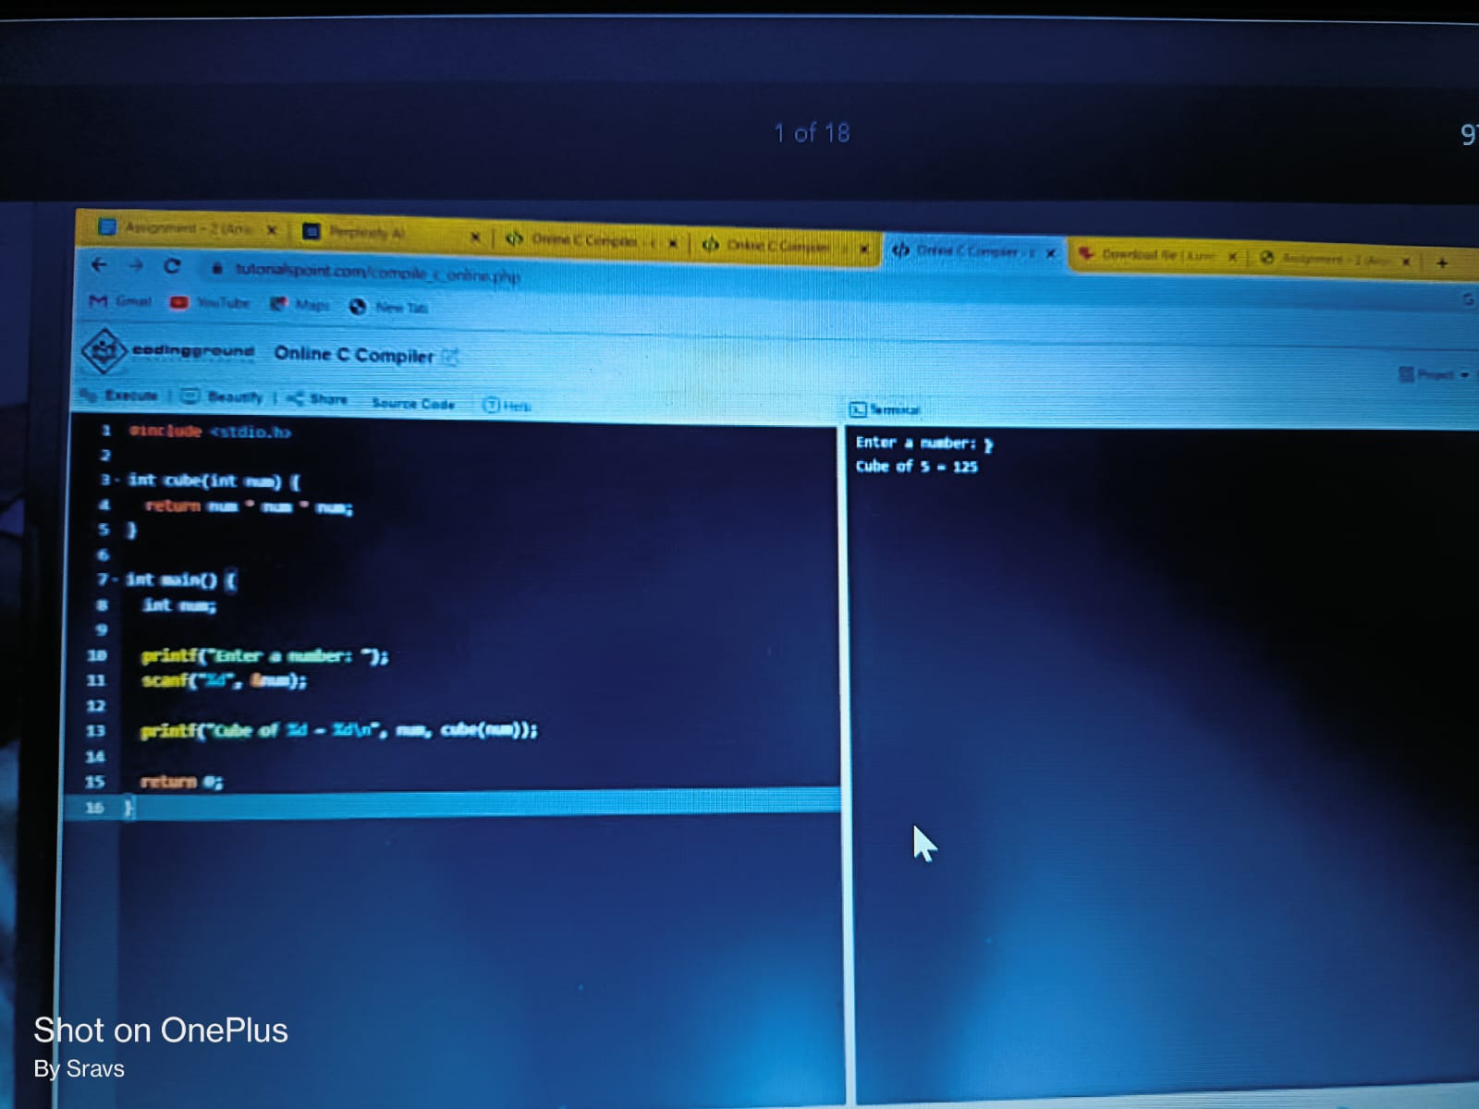

1. Write a C program to input radius of circle from user and find diameter, circumference and area of the given circle using function. How to find diameter, circumference and area of a circle using function in C programming.

**Example**

**Input**

Input radius: 10

**Output**

Diameter = 20 units

Circumference = 62.83 units

Area = 314.16 sq. units

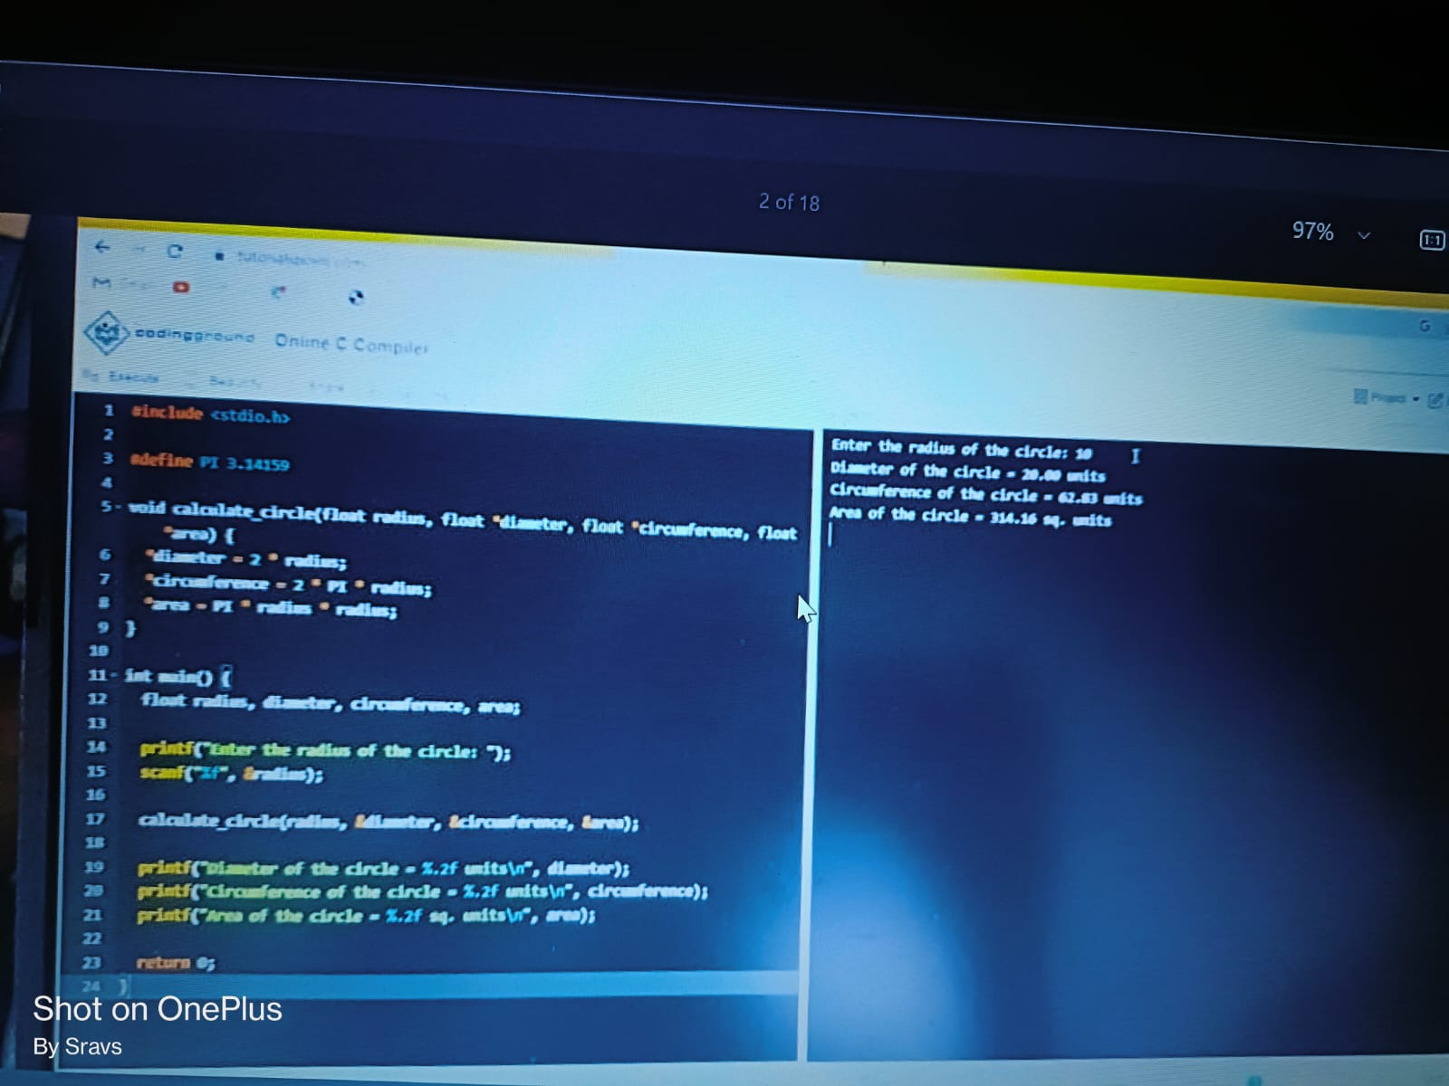

1. Write a C program to input two or more numbers from user and find maximum and minimum of the given numbers using functions. How to find maximum and minimum of two or more numbers using functions in C programming.

**Example**

**Input**

Input two numbers: 10

20

**Output**

Maximum = 20

Minimum = 10

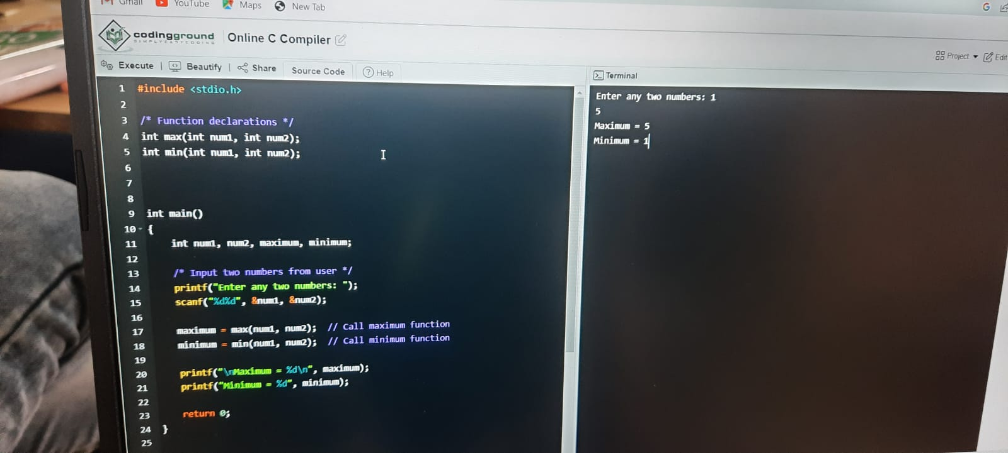

1. Write a C program to input a number from user and check whether given number is even or odd using functions. How to check even or odd using functions in C programming. Write a function in C programming to check even or odd.

**Example**

**Input**

Input any number: 10

**Output**

10 is even

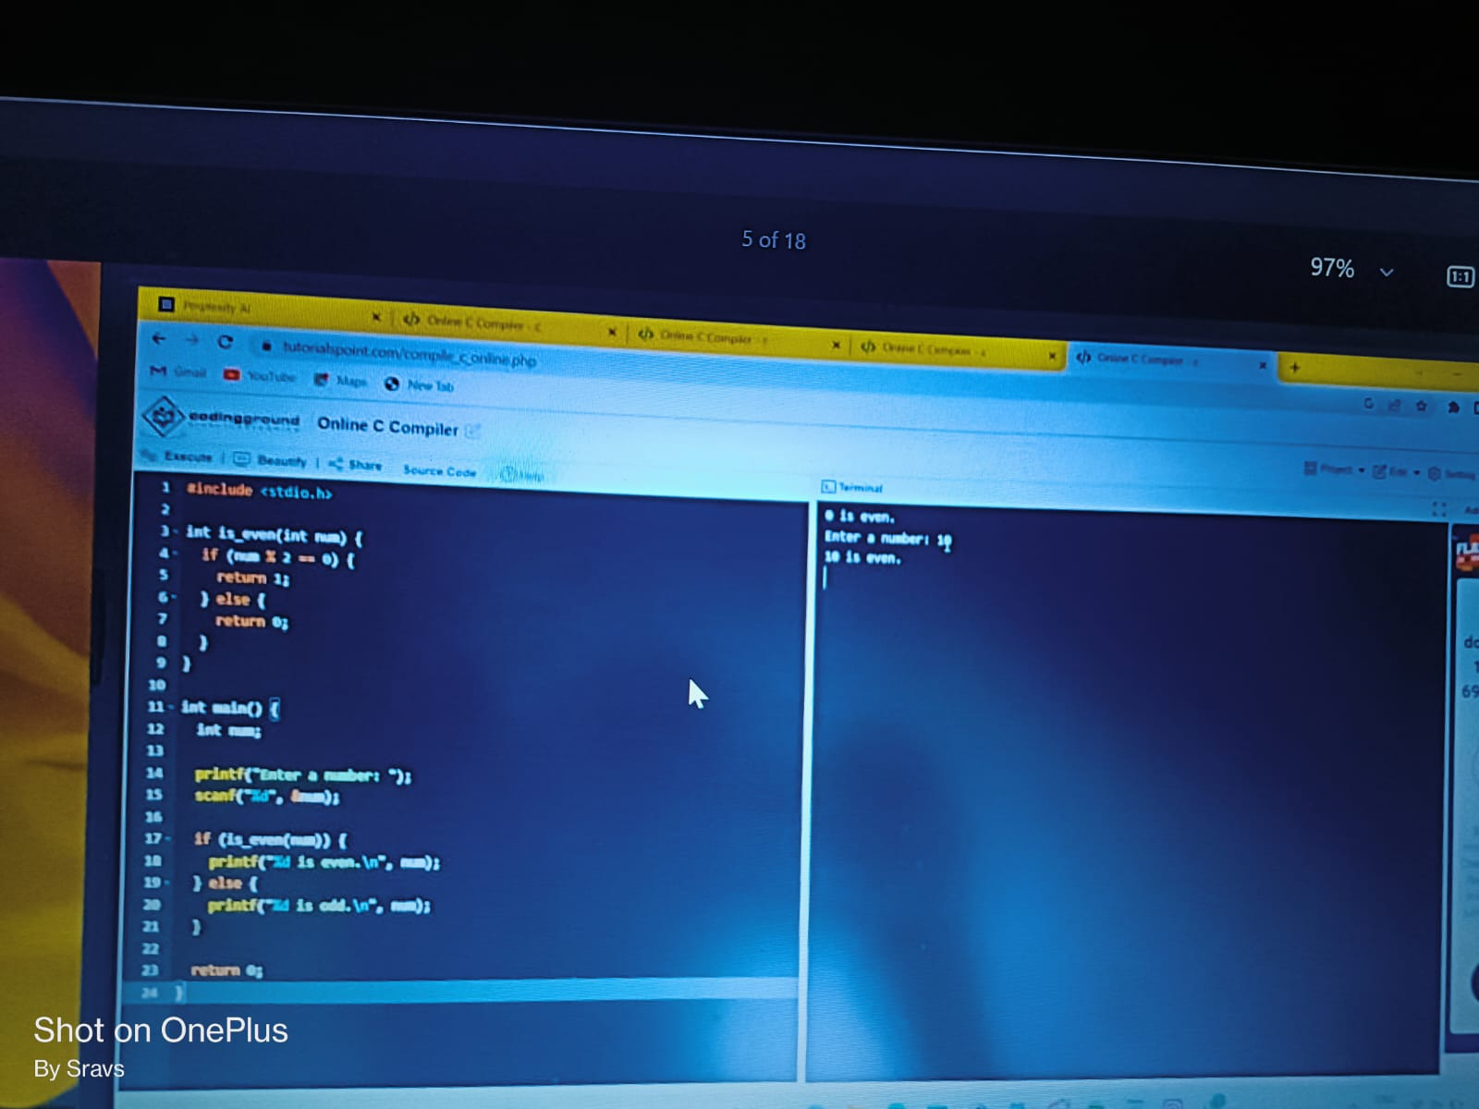

1. Write a function in C programming to find prime numbers using function. How to find all prime numbers between two intervals using functions. Display all prime numbers between a given range using function in C programming.

**Example**

**Input**

Input lower limit: 10

Input upper limit: 50

**Output**

Prime numbers between 10-50 are: 11, 13, 17, 19, 23, 29, 31, 37, 41, 43, 47

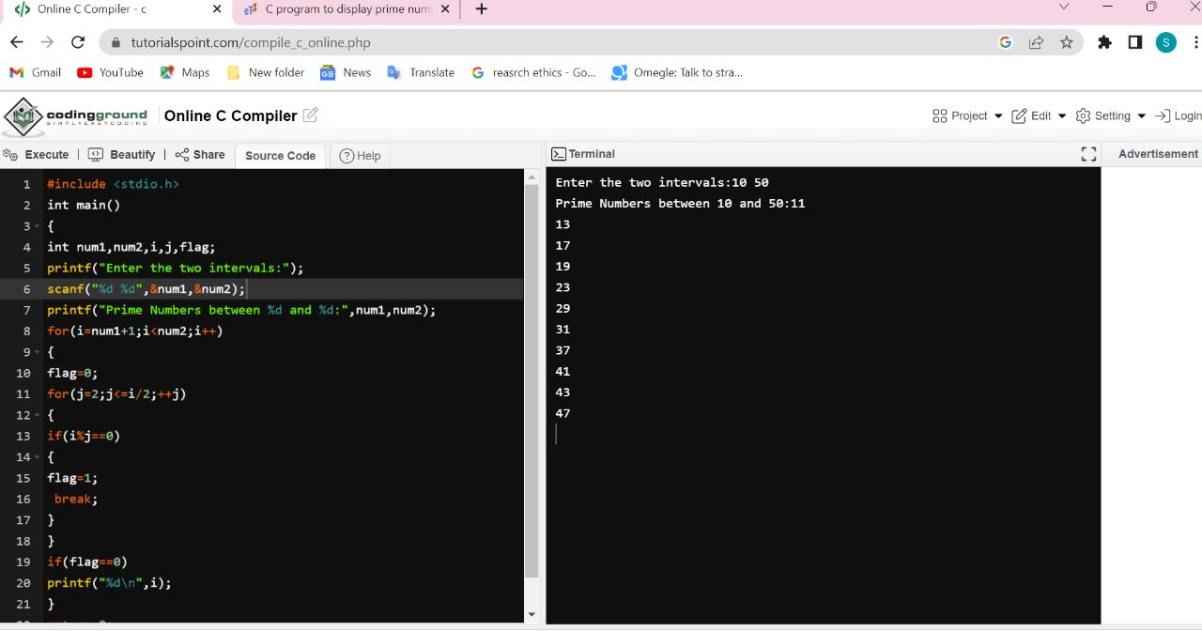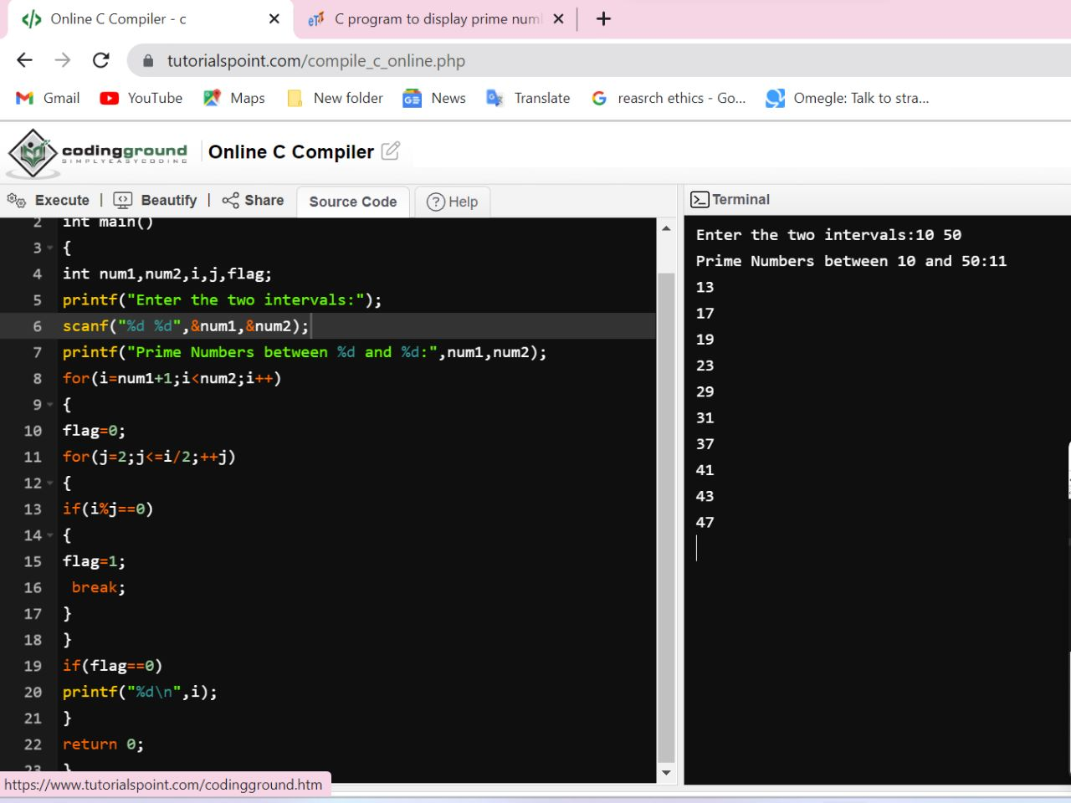

1. Write a C program to print all strong numbers between a given interval in C programming. How to print strong numbers in a given range using functions in C programming. Write a C function to find strong numbers between 1 to n.

**Example**

**Input**

Input lower limit: 1

Input upper limit: 1000

**Output**

Strong numbers between 1 to 100: 1, 2, 145

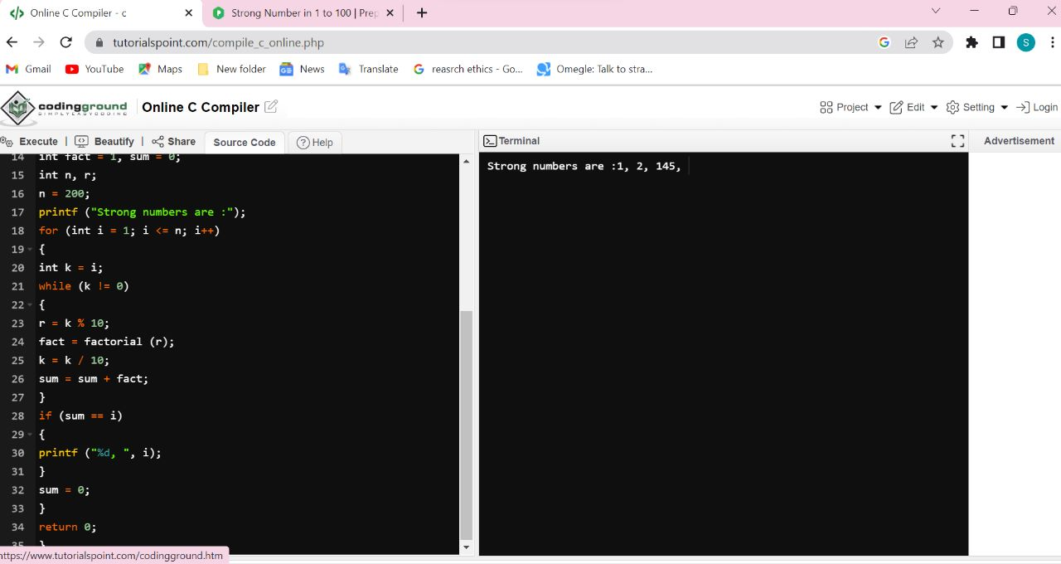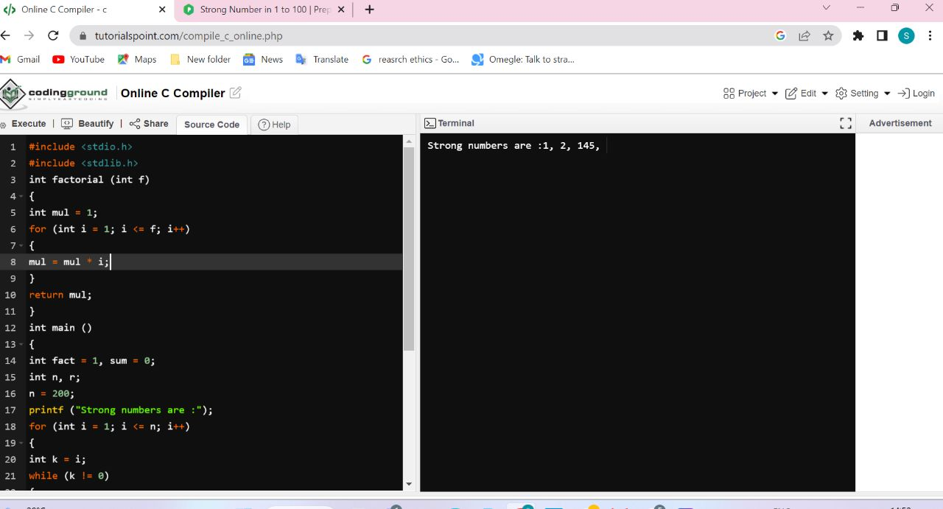

1. Write a function to print all Armstrong numbers between given interval in C programming. How to print all Armstrong numbers in given range using functions in C programming. C function to print all Armstrong numbers from 1 to n.

**Example**

**Input**

Input lower limit: 1

Input upper limit: 1000

**Output**

Armstrong numbers between 1 to 1000 are: 1, 153, 370, 371, 407,

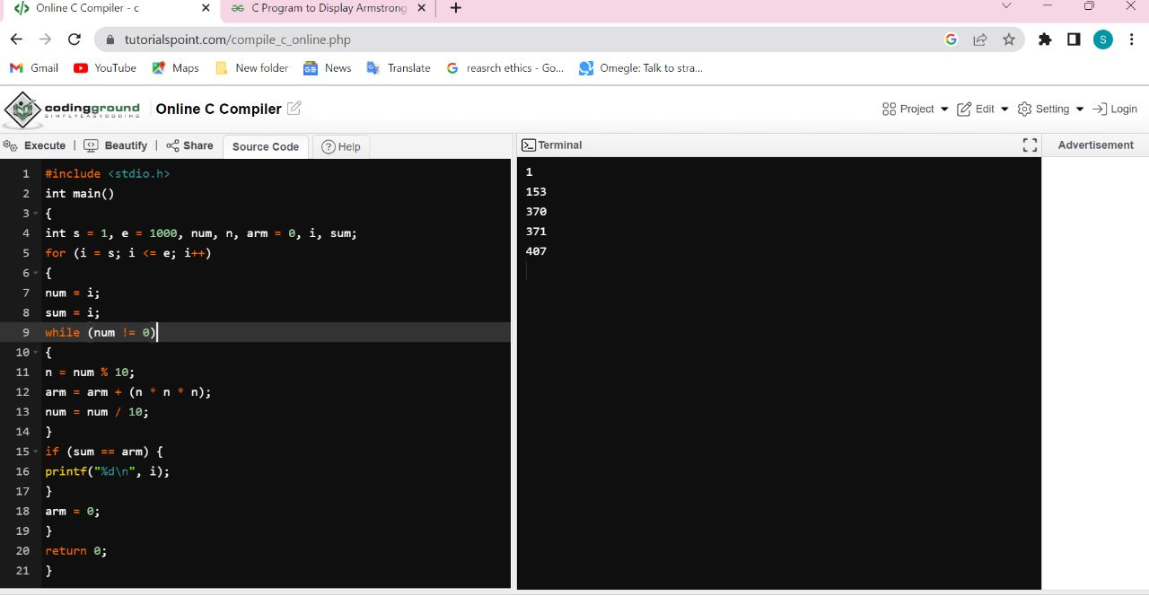

1. Write a C program to input a number from user and find power of given number using recursion. How to find power of a number using recursive function in C programming. Logic to find power of a number using recursion in C programming.

**Example**

**Input**

Input base number: 5

Input power: 2

**Output**

2 ^ 5 = 25

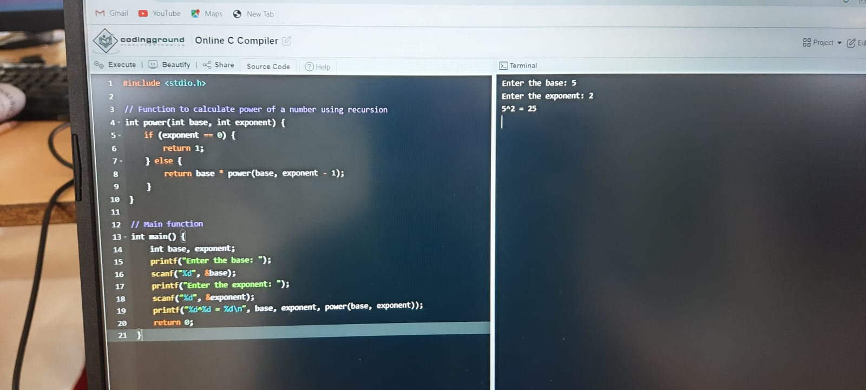

1. Write a recursive function in C programming to print all natural numbers between 1 to n. How to print all natural numbers from 1 to n using recursion in C program. Logic to print all natural numbers in given range using recursion in C programming.

**Example**

**Input**

Input lower limit: 1

Input upper limit: 10

**Output**

Natural numbers between 1 to 10: 1, 2, 3, 4, 5, 6, 7, 8, 9, 10,

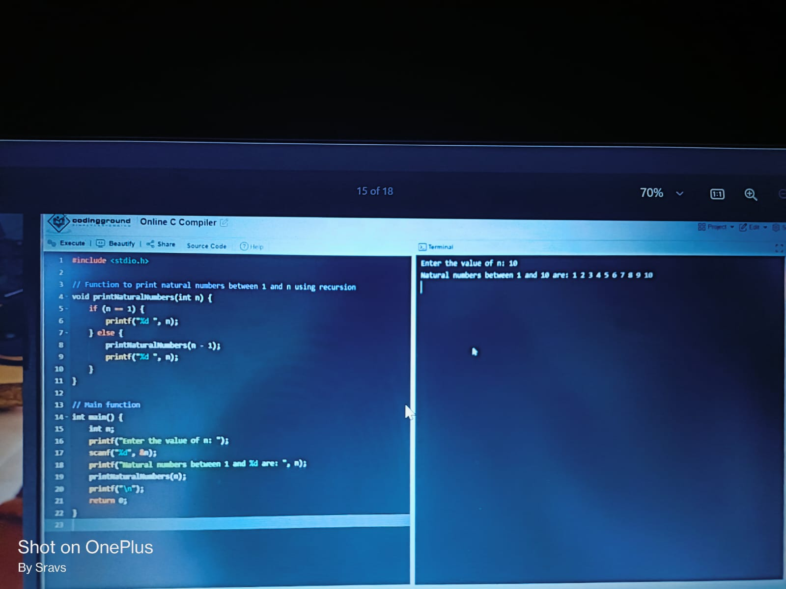

1. Write a recursive function in C programming to print all even or odd numbers between 1 to n. How to print all even numbers in given range using recursion in C programming. Logic to print even/odd numbers in given range using recursion.

**Example**

**Input**

Input lower limit: 1

Input upper limit: 10

**Output**

Even numbers between 1 to 10: 2, 4, 6, 8, 10

Odd numbers between 1 to 10: 1, 3, 5, 7, 9

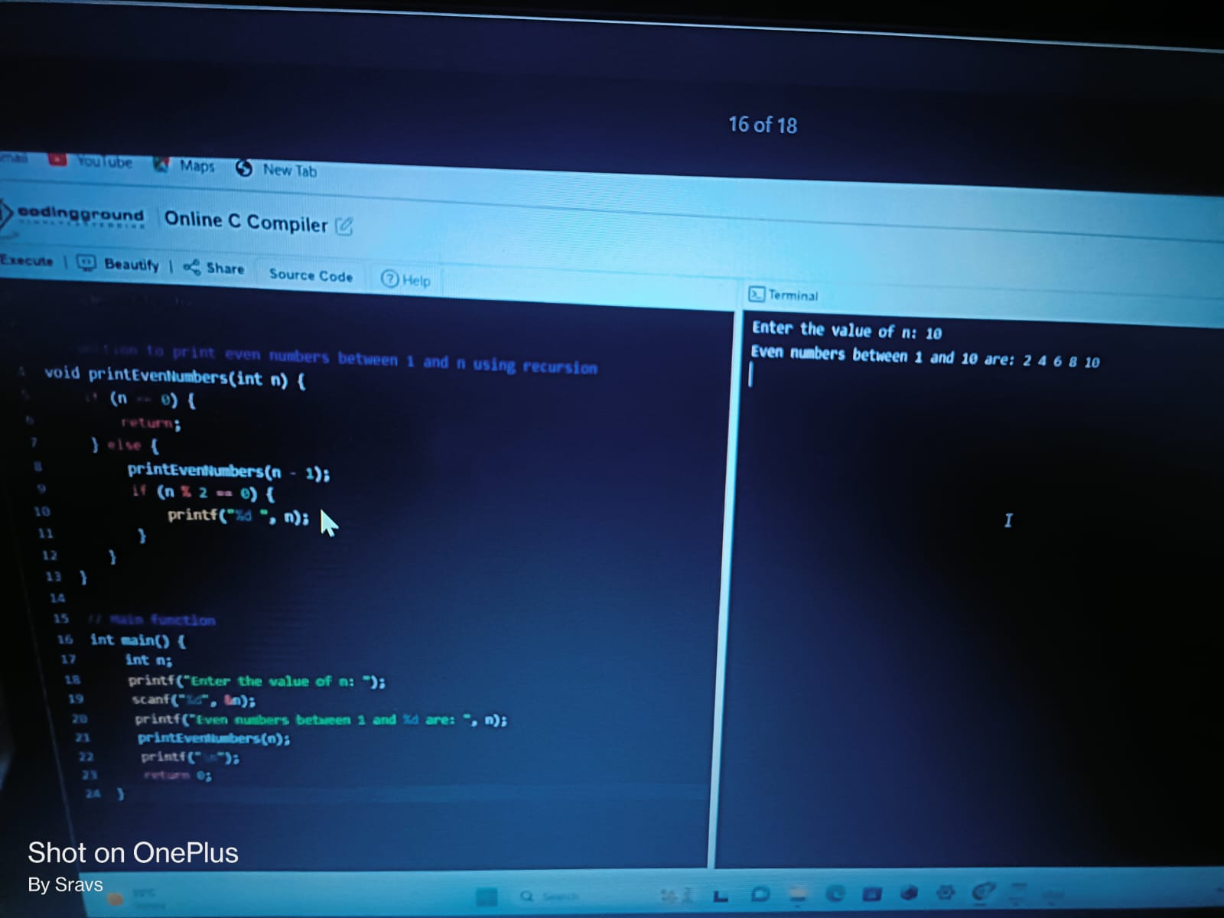

1. Write a C program to check whether a number is prime, armstrong, perfect number or not using functions. How to check prime or armstrong or perfect number in C programming using functions.

**Example**

**Input**

Input any number: 11

**Output**

11 is prime number

11 is not a armstrong number

1. s not a perfect number

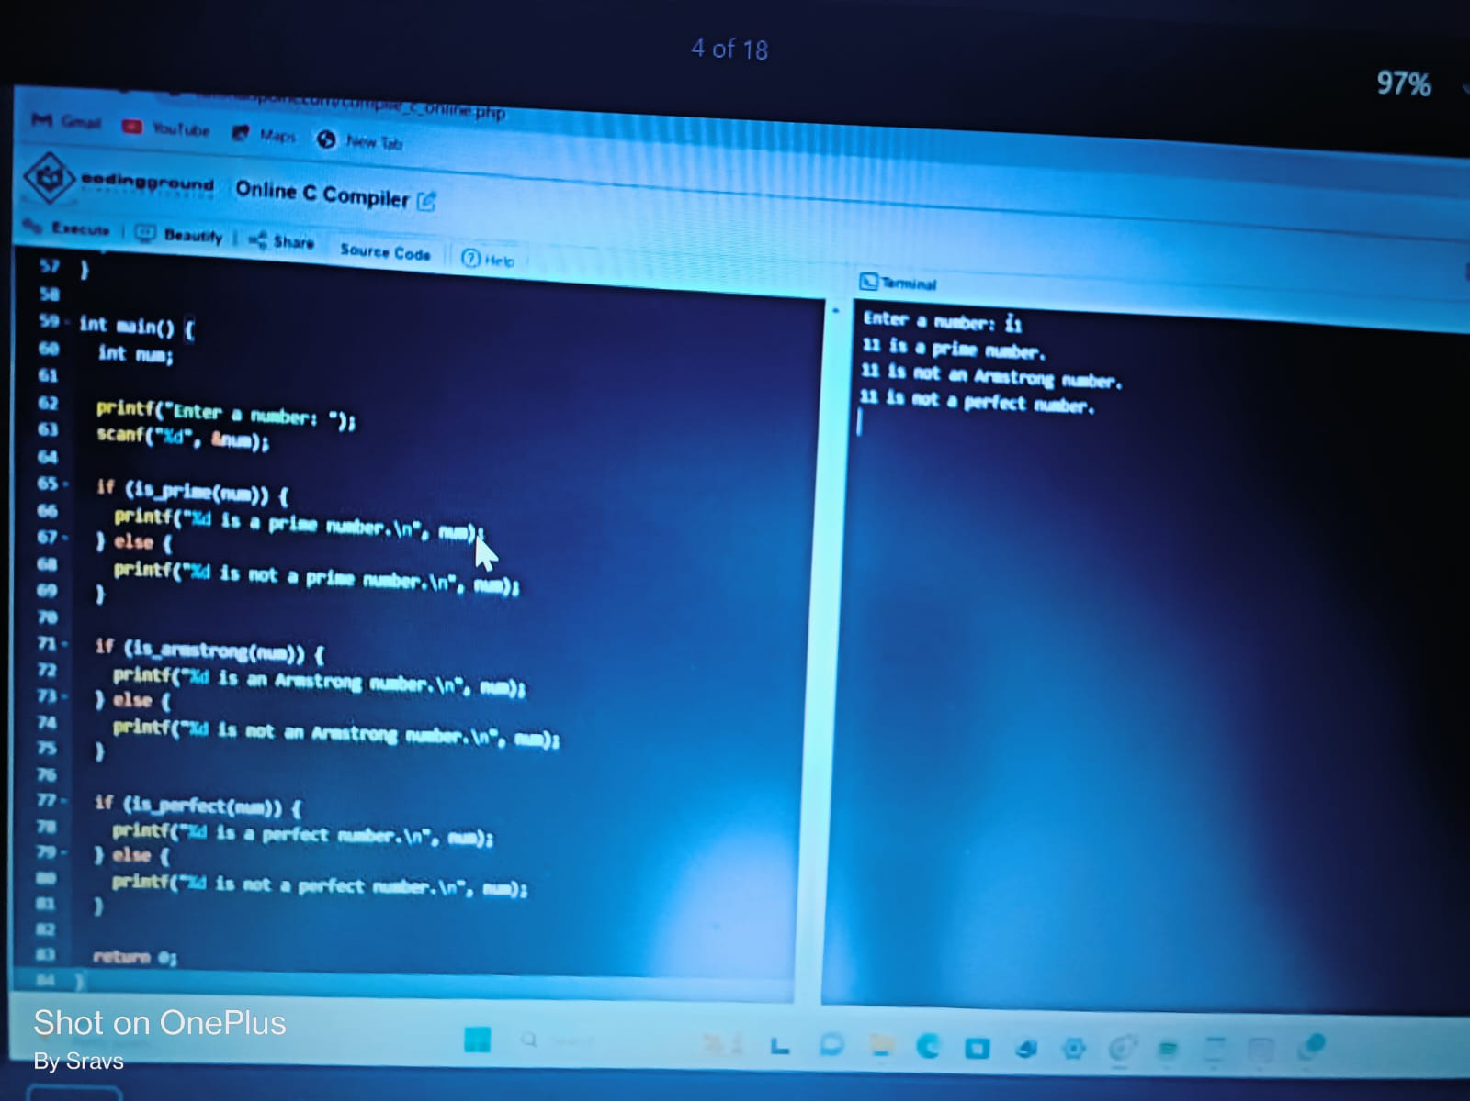

1. Write a function to print all perfect numbers in a given interval in C programming. How to print all perfect numbers in a given range using functions in C program. C program to print all perfect numbers between 1 to n using functions.

**Example**

**Input**

Input lower limit: 1

Input upper limit: 100

**Output**

Perfect numbers: 6, 28

